How to make Data-Driven decisions with LinkedIn Analytics

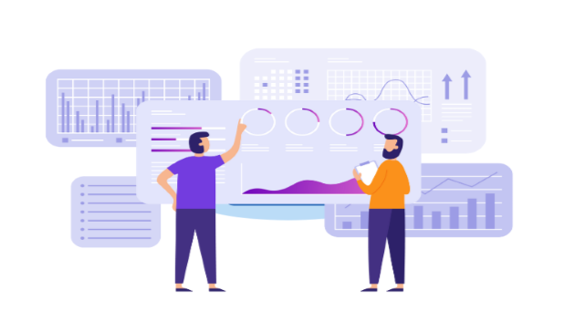

Have you ever wondered how your profile is doing on LinkedIn? Do you appear in the search pages? Or is your company page garnering enough attention?

Questions like these often come to mind when your purpose of being on LinkedIn would be to find a job, grow your customer base or grow yourself professionally.

But how can you measure all of these? That is when LinkedIn Analytics comes into the picture. LinkedIn analytics shows the data & statistics behind your LinkedIn activity. This can further help you understand how your content is performing & how your audience is interacting with it. This blog will be your LinkedIn Analytics Guide to help you understand how you can effectively boost your LinkedIn profile.

LinkedIn Page Analytics include the following:
- LinkedIn Content Performance: It shows the effectiveness & evaluates the quality of content that is shared on your page.
- LinkedIn Followers Insights: This shows the demographics & sources of your followers to help you understand them better to engage with them.
- LinkedIn Visitor Analytics: To help you understand the visitors to your page & to convert them into followers
- LinkedIn Lead Generation Strategy: Helps you collect quality leads from members who visited your page
- Competitors: This helps you compare the analytics of your page with that of your followers.

Steps to make data driven decisions:
Access LinkedIn analytics page
Log in to your LinkedIn Page. Then navigate to your profile or your company profile. Select ‘Posts & Activity’ for personal pages or ‘Analytics’ for company pages. You will be taken to the Analytics section where you can see data & insights about your profile or company page, including post performance, follower demographics, & more. Then explore the different tabs & options to see all the data available to you.

Set objectives
Your objectives may vary from the growth of your page to increasing brand awareness or generating leads & increasing website traffic. It is very important to be clear about your objectives because this helps to measure them effectively.

Your objectives should be SMART (Specific, Measurable, Attainable, Relevant & Time - bound)

KPI- Key Performance Indicators
You must determine which metrics align with your goals. Key metrics may include profile views, connection growth, post reach, engagement, click-through rate, follower growth, demographics, content performance, follower growth & conversion rate. With such a wide range of metrics available, understanding what works the best for you is important.

For example, if your goal is to increase brand awareness, metrics like impressions & reach are important. But if you're focused on lead generation, metrics like click-through rate & conversion rate are crucial.

Analyze your data
Regularly reviewing your LinkedIn Analytics can help you in measuring LinkedIn engagement to track the performance of your posts, content types, & audience demographics. Look for patterns & trends to understand what is working & what is not.

This will help you identify the top performing content. Then you can tailor your content better to meet the needs & interests of your target audience.

Experiment with your strategy
By using the insights from your analytics, you can refine your LinkedIn strategy. Testing different types of content, posting times, & audience targeting will help you to optimize your results.
Once you have your analytics in place, use the PaintMinds LinkedIn Optimization Tool to optimize your profile to best suit your efforts.

Competitors are your best friends
To better achieve your targets, you must view your competitors as your best friends. Yes, you heard that right!

By watching your competitors’ LinkedIn activity & analyzing their performance metrics, you can improve your performance. Competitor analysis provides valuable benchmarking insights & ideas for improvement.

Adjust your strategies
Learning does not stop & likewise your strategies should not stop too! You need to continuously adjust your LinkedIn strategy based on the data you collect. Focus on tactics that drive the highest engagement & ROI & be willing to adapt to changes in the platform & your target audience.

Keep up with changes to LinkedIn's algorithms, features, & best practices to ensure that your strategy remains effective over time.

By following these steps & leveraging the data provided by LinkedIn Analytics, you can make informed decisions to optimize your presence on the platform & achieve your business objectives.

PaintMinds brings to you an exclusive tool to optimize your LinkedIn profile. As per research, daily 95% of recruiters rely on LinkedIn to identify the right fit for their organizations! An optimized LinkedIn Profile would help you build a personal brand, generate high-quality leads, garner credibility & have better networking opportunities across industries. So, what are you waiting for? Visit the PaintMinds website right away to build your LinkedIn Profile!

Keywords: LinkedIn analytics guide | Measuring LinkedIn engagement | LinkedIn content performance | LinkedIn lead generation strategy | LinkedIn visitor analytics | LinkedIn follower insights

Title Tag: Your Guide to LinkedIn Analytics

Meta Description: Your LinkedIn Profile can speak so much about you. Want to kno the right way to optimize your profile according to your LinkedIn analytical data? Read this blog to know how LinkedIn Analytics works.

Meta Tag: LinkedIn Analytics – How can it help you make data-driven decisions? | PaintMinds

